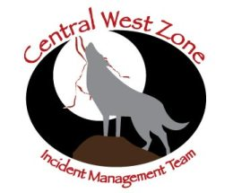
Osha Fire News Release
June 6, 2011 7:00 p.m.
Fire Information: 575-758-6345
8:00 a.m. to 4:30 p.m.

Miller Fire News Release

Acres: 720 Start date: June 1, 2011
Cause: Human Location: 4 miles east of Penasco, NM
Containment: 94 percent Fuels: Mixed conifer and pine
Terrain: Steep, rugged Resources: 10 crews, 2 engines, 1water tenders, 2 dozers
Total personnel: 331 Available air support: 1 helicopter

As the firelines on the Osha Fire held secure, firefighters continued to mop-up and patrol the perimeter today. Other crews continued to locate and recover equipment. Rehabilitation of firelines is continuing where appropriate.

At 6:00 a.m. tomorrow, the management of the Osha Fire will transition from the Arizona Central West Zone Incident Management Team to Paul Delmerico’s Type III Incident Management Team. For fire information, please call 575-758-6345 from 8 a.m. to 4:30 p.m.

Fire behavior for tomorrow is expected to be minimal as firefighters continue mop-up and rehabilitation efforts. Fire related traffic will continue around the fire and in the community. Please be alert and drive safely. The Forest closure continues to be in effect for the restricted areas surrounding the fire, including all Forest Service roads and developments including campsites and parking areas.

The Arizona Central West Zone Incident Management Team would like to thank the communities affected by the fire for their support during this incident.

Additional information and maps may be found at: www.inciweb.org

*End*

